CHINESE FLAGSHIP SECONDARY CURRICULUM
LEVEL 4 - AN INTERCONNECTED WORLD

Unit : 2 Technology and Contemporary Life
Integrated Performance Assessment

Novice Novice Novice Intermediate Intermediate Intermediate
Low ➔ Mid ➔ High ➔ Low ➔ Mid ➔ High➔

Learning Targets:

- I can read and understand varieties of Chinese content such as online advertisements and
warning signs.
- I can do online shopping from Chinese websites
- I can talk about computer/information technology in some detail.
- I can present my opinions about my e-life.

Task Overview
Your friend Meiyu Wang has been studying abroad in China for more than two years now. She has been learning Chinese while traveling to certain destinations. She has visited many museums and also somewhat understands China’s natural environment. Although you really want to talk to her in Chinese, you can only correspond with her through email.
Now, you have a new smartphone so you can access the internet anytime, anywhere. Therefore, you downloaded many mobile applications; this way you can not only learn more about Chinese culture and watch Chinese movies, but also you can understand more about society through video communication with Meiyu Wang and learn about online shopping in China, etc. Because you are becoming more and more interested in China, you finally decide to travel to China. You tell your detailed travel plans to Meiyu Wang.

Interpretive Reading Task (Reading text, plus comprehension questions):
After you got a new smartphone, you can now contact Wang Mei Yu more easily. She often tells you about the interesting things that she sees and hears every day. She encourages you to learn your Chinese well. One day, she sent you pictures she took of advertisements she saw, and also asked you to answer some questions.

http://pic47.nipic.com/20140827/10779892_192808617000_2.jpg
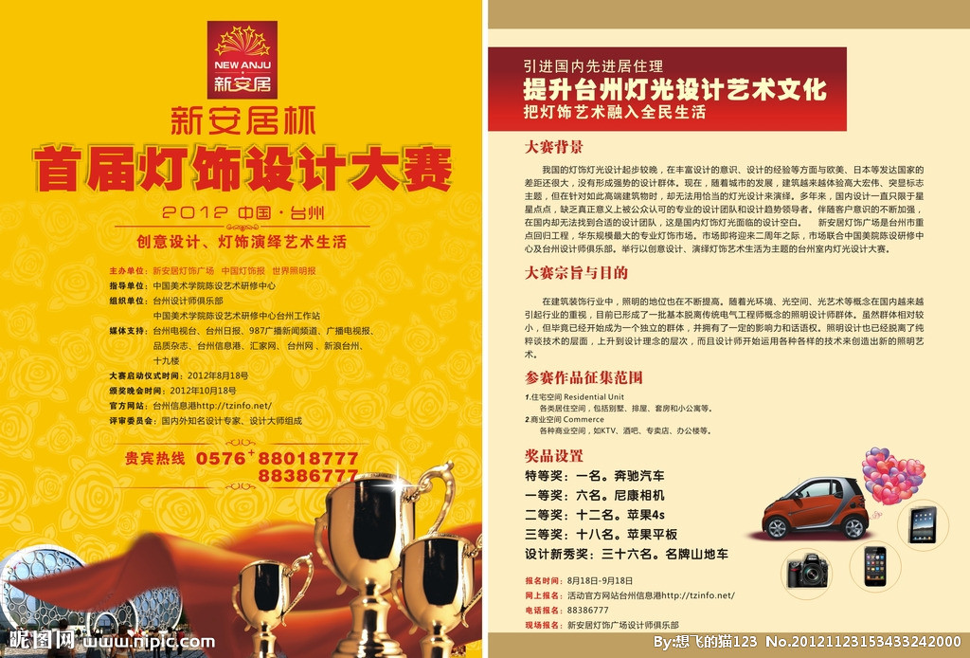
http://pic25.nipic.com/20121123/5094734_153433242000_2.jpg
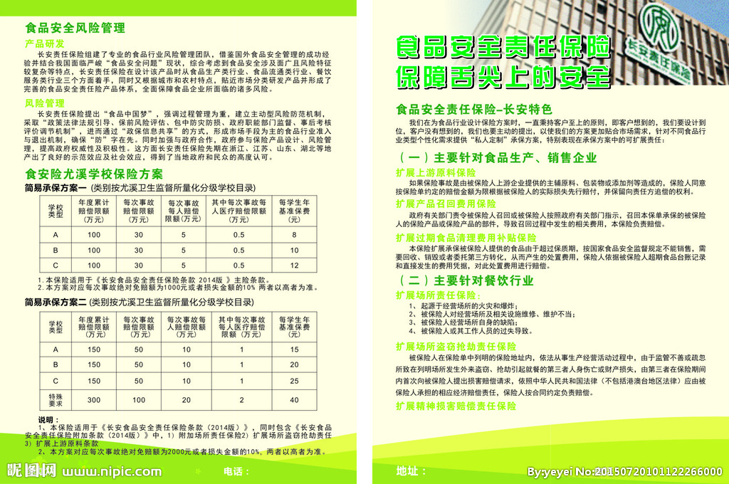
http://pic72.nipic.com/file/20150720/3487493_101122266000_2.jpg

- What is the similarities and differences between these advertisements?
- What kind of people will be interested in these advertisements?
- What are these advertisements want to tell you?
- Where do you think the three advertisements are from? Why?

Interpersonal Listening and Speaking Task:
When you search for Chinese information, you realize that Baidu is better than Google, and when you search for English information, it is just the opposite. So, you and Meiyu Wang often use video chat to discuss the uses of similar applications and programs that are alike in Chinese and English. You guys also often discuss interesting everyday life occurrences.

(Extension) Interpersonal Writing Task:
You’re interested in online shopping in China. Use wechat to communicate with your peers pretending you are the online shopping seller or the buyer. Teachers need to get permission from parents to use wechat in this activity.

Presentational Writing Task:
You have started to become interested in Chinese film. After watching some Chinese movies, you write about a movie in Google Classroom in order to introduce the movie to your classmates.

Presentational Speaking Task
Finally, you decide to travel to China during summer break and consequently come up with a plan to travel to Beijing by car. You first booked a flight ticket and hotel room online and then used Baidu and Google Maps to determine a specific travel route. After everything is ready to go, you can’t wait to tell Meiyu Wang your plan. But because of time difference she was still sleeping, and you left her a voice message telling her your detailed plans.

